Preview of table hourly contracts before normalization:

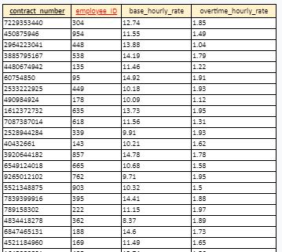

Table is already in 1NF, 2NF and 3NF, doesn’t need to be normalized.

PK is contract_number.

FK is employee_ID.

Preview of table after normalization:

